**Project Documentation**

**Cook Book:Your Virtual Kitchen Assistant**

**1. Introduction:**

**Project Title: CookBook: Your Virtual Kitchen Assistant**

**Team ID: NM2025TMID40007**

**Team Leader:**

**Sharmila.S**

**[** [**sac2427csc5342@ssacollegechennai.com**](mailto:sac2427csc5342@ssacollegechennai.com) **]**

**Team Members:**

**Shabana.A**

**[** [**sac2427csc5315@ssacollegechennai.com**](mailto:sac2427csc5315@ssacollegechennai.com) **]**

**Sangavi.G**

**[** [**sangavisangavi394@gmail.com**](mailto:sangavisangavi394@gmail.com) **]**

**Shivasankari.K**

**[ sac2427csc5327@ssacollegechennai.com ]**

**2. Project Overview:**

**Purpose:**

* **CookBook is designed to be more than just a recipe manager-it acts as a smart culinary guide.It helps users discover new dishes,track their cooking progress,and customize meals according to their dietary preferences. The goal is to make cooking easier,healthier and more enjoyable by combining recipe management with personalization.**

**Features:**

* **Advanced search by dietary needs (vegan, keto, gluten-free, etc.)**
* **Step-by-step cooking mode with timers and voice guidance**
* **Smart Recipe rating, reviews, and community sharing**
* **ingredient substitution suggestions**
* **Weekly meal planner with nutritional breakdown**

**3. Architecture:**

**Frontend:**

* **React.js + Tailwind CSS for a responsive and modern UI**
* **Redux ToolKit for state management**
* **Axious for API communication**

**Backend:**

* **Node.js + Express.js for REST APIs and server-side logic**
* **GraphQL(Optional extension)for flexible queries**

**Database:**

* **MangoDB for recipes,users,and collections**
* **Redis for caching frequently accessed recceips and speeding up search**

## 4.setup instructions:

**Prerequisites:**

**– Node.js**

**– MongoDB**

**– Git**

**– Visual Studio Code**

**Installation Steps:**

**# Clone the repository**

**git clone**

**# Install client dependencies**

**cd client**

**npm install**

**# Install server dependencies**

**cd ../server**

**npm install**

**5. Folder Structure:-**

**cookbook/**

**├── client/ # React frontend**

**│ ├── components/**

**│ ├── pages/**

**│ └── assets/**

**├── server/ # Node.js backend**

**│ ├── routes/**

**│ ├── models/**

**│ ├── controllers/**

**│ └── middleware/**

**└── README.md**

**6. Running the Application:-**

**Frontend:**

**cd client**

**npm start**

**Backend:**

**cd server**

**npm start**

**Access: Visit http://localhost:5173**

**7. API Documentation:-**

**User:**

**POST /api/user/register – Create account**

**POST /api/user/login – Log in**

**Recipes:**

**POST /api/recipes/upload – Upload recipe**

**GET /api/recipes/:id – Get recipe details**

**Collections:**

**POST /api/collections/create**

**GET /api/collections/:userId**

**8. Authentication:-**

**JSON Web Token (JWT) for login sessions**

**Middleware to protect private routes**

**9. User Interface:-**

* **Landing Page with featured recipes**
* **Recipe Page with ingredients and instructions**
* **Collection Dashboard**
* **Admin Panel for recipe moderation**

**10. Testing:-**

* **Manual testing for recipe upload, search, and collection creation**
* **:Tools: Postman, Chrome DevTools, Jest for unit tests**

**11. Screenshots or Demo**

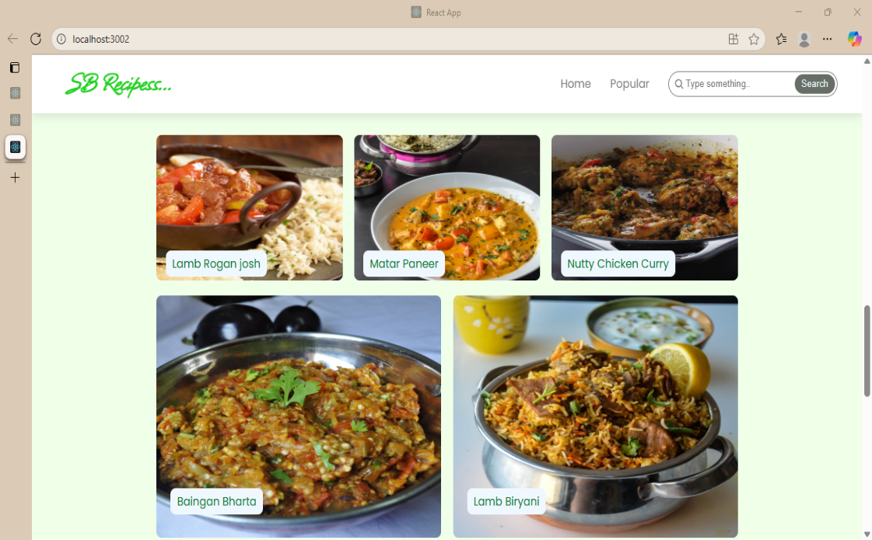

**12. Known Issues:-**

* **Occasional lag when loading recipes with high-resolution images**
* **Limited support for slow or unstable internet connections**
* **Search filters may return incomplete results with very large datasets**
* **Cross-device synchronization of favorites and history not always consistent**

**13. Future Enhancements:-**

* **AI-driven nutrition tracker with custom health-focused meal plans**
* **integration for instant shopping list creation and delivery options Grocery**
* **AR/VR-based immersive cooking guidance for real-time assistance**
* **IoT integration with kitchen devices (smart ovens, smart fridge, etc.)**
* **Gamified experience with badges, challenges, and cooking streaks**
* **Dedicated mobile-first app with offline recipe access and push notifications**